**Purpose** - This document provides details of the COSMIIC Smart Charger (SC) features and functions.

**Scope** - This document covers the Smart Charger Rev A design as of May 2024.

**Referenced Documents**

- LAB 2 Rev B Details 220310.docx

- Closed Loop Battery Charger Prototype Details 230608.docx

- SC Rev A Power Diagrams 240803.pptx

- INA236 Shunt R 240809.xlsx

- TPS55289EVM-093 Vout Set Math 230628.xlsx

**Definitions and Terminology**

- CT - Control Tower

- LAB2 - LaunchPad Adapter Board

- MedRadio - Medical Device Radiocommunications Service

- NNP - Networked Neural Prosthesis

- PM - Power Module

- uC - Microcontroller

**Background** - The Networked Neural Prosthesis (NNP) is an implanted distributed networked system that provides stimulation and sensing for restoration of function. The implanted Power Module (PM) provides bidirectional communications with external systems using the MedRadio band (402-405 MHz).

The NNP PM receives power for recharging its batteries, and providing operating power, through a loosely coupled inductive link. The inductive link is realized by two coaxially aligned coils, one in the implanted PM, and one externally worn recharge coil positioned over the implanted PM. This resonant wireless power transfer provides several hundred milliwatts of power over coil displacements up to 5cm.

Clinically, this PM battery recharging system is provided by the Control Tower (CT). The CT has coil drive circuitry, as well as a MedRadio link for bidirectional communications with the PM. The CT also has a small graphical display, which provides system status to the user. The CT is a large (9.3 x 11.1 x 1.7 in) multifunction device.

We also developed a series of smaller coil drive systems (6.1 x 4.3 x 1.5 inch) based on the Texas Instruments MSP430 LaunchPad evaluation system. The LaunchPad Adapter Board system (LAB) was developed to allow control of the coil drive circuitry by a Texas Instruments (TI) LaunchPad series development kits. Details of the most current LAB 2 can be found in “LAB 2 Rev B Details 220310.docx”.

**Introduction** - We developed a series of smaller coil drive systems (6.1 x 4.3 x 1.5 inch) to use for various development efforts. The LAB 2 utilizes the MSP430F5529 LaunchPad board as the processor. It interfaces with Mathworks tools through a USB based UART. We used the LAB 2 for the development of a prototype Closed Loop Battery Charger (CLBC) for the COSMIIC grant. A simplified block diagram of the CLBC is illustrated in Figure 1.

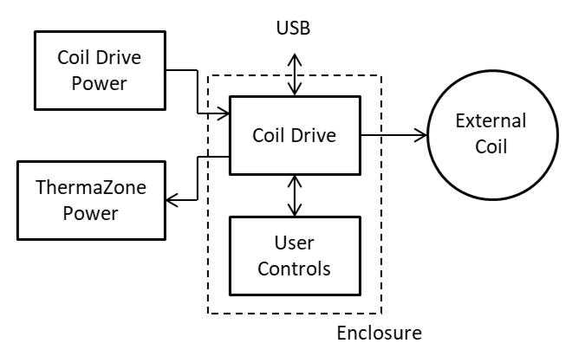

Figure 1. Simplified Block Diagram of the Closed Loop Battery Charger.

The CLBC system is a small enclosure that contains the coil drive circuitry and provides various user inputs and outputs. It is powered by a desktop AC adapter, which can also provide power to the ThermaZone coil-cooling device. The CLBC provides the necessary functions for charging the NNP Power Module. A system diagram of the CLBC is shown in Figure 2.

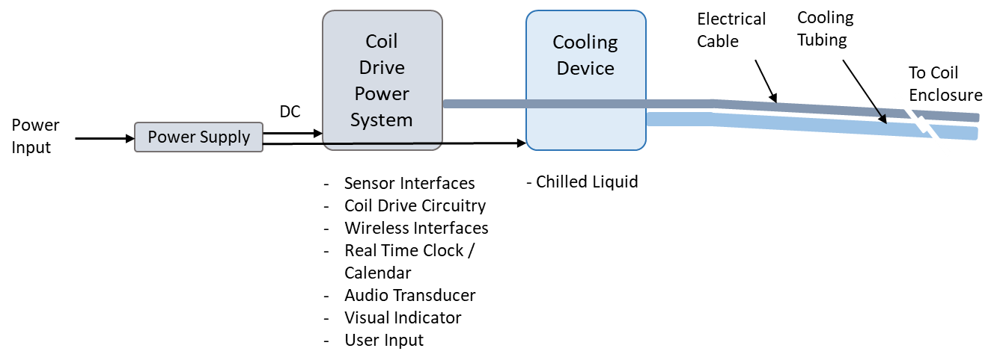

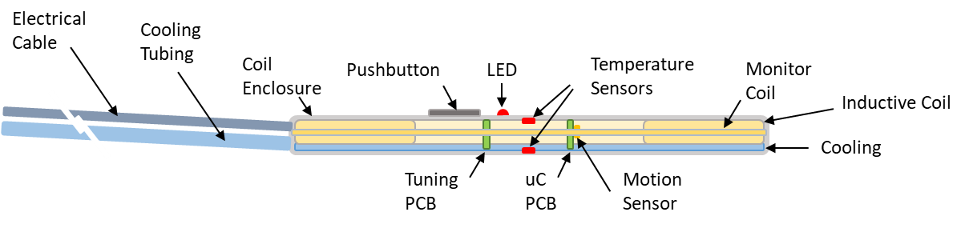

Figure 2. Closed Loop Battery Charger System Diagram.

**Closed Loop Battery Charger Prototype** - A proof of concept prototype of the CLBC meeting many of the requirements of the COSMIIC grant was developed based on the LAB 2 system. Details of the CLBC can be found in “Closed Loop Battery Charger Prototype Details 230608.docx”. Photographs of the prototype CLBC are presented in Figure 3.

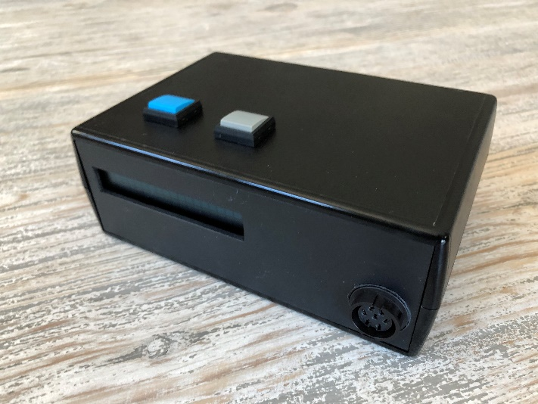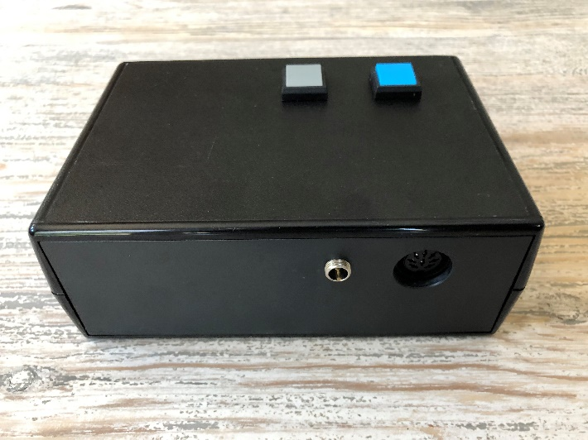

Figure 3. Closed Loop Battery Charger Prototype Enclosure.

The CLBC prototype was fabricated in a larger 6.1 x 4.3 x 2.25 inch enclosure to accommodate all of the circuitry. A photo of the circuitry is presented in Figure 4.

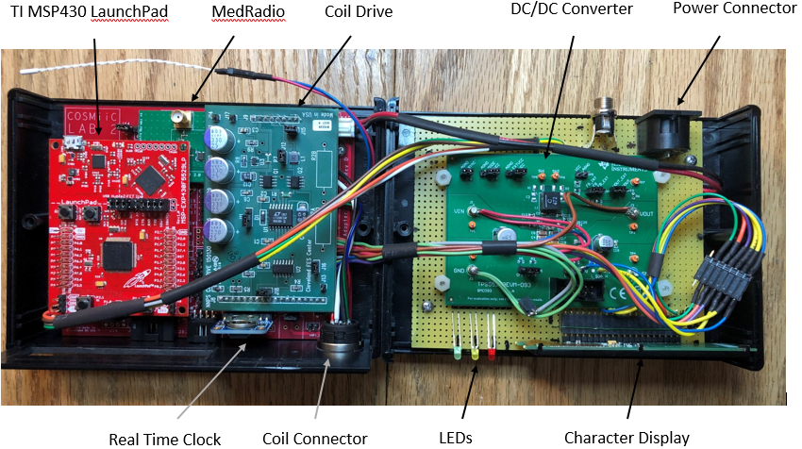

Figure 4. Closed Loop Battery Charger Prototype Circuitry.

A detailed block diagram and list of features of the CLBC prototype is presented in Figure 5.

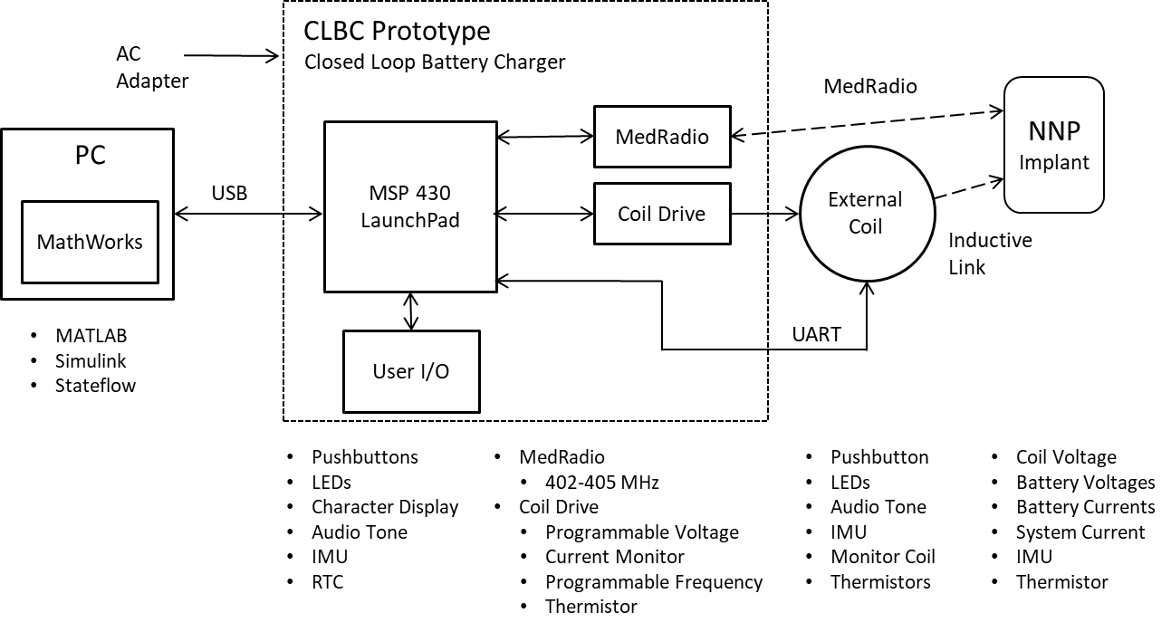

Figure 5. Block Diagram of the Closed Loop Battery Charger Prototype.

The CLBC prototype adds a Coil Drive Power DC/DC converter, whose voltage is set by the uC, to the LAB 2. It also adds a 2 x 20 character display, three LEDs, and two pushbuttons to the user I/O. The CLBC also can control the enhanced smart recharge coil.

The CLBC prototype demonstrated that the smaller form factor battery charger with enhanced features was well accepted. It provides features not realized with the current Control Tower. An enhanced version of this approach has been developed and is known as the Smart Charger.

**Smart Charger Overview** - The Smart Charger (SC) is an enhancement of the CLBC prototype. In particular, it was decided to use the Wireless Link as the main processor. The Wireless Link (WL) is a small, self contained, two button wireless interface that has been developed for control of the NNP implant system. The WL is fabricated on a single 2.6” x 1.8” PCB. It features an Arm based uC and various wired and wireless interfaces. Using the WL as the SC processor allows us to leverage the software development effort of the WL. The SC functions are a superset of the WL.

A block diagram and list of features of the SC system is presented in Figure 6.

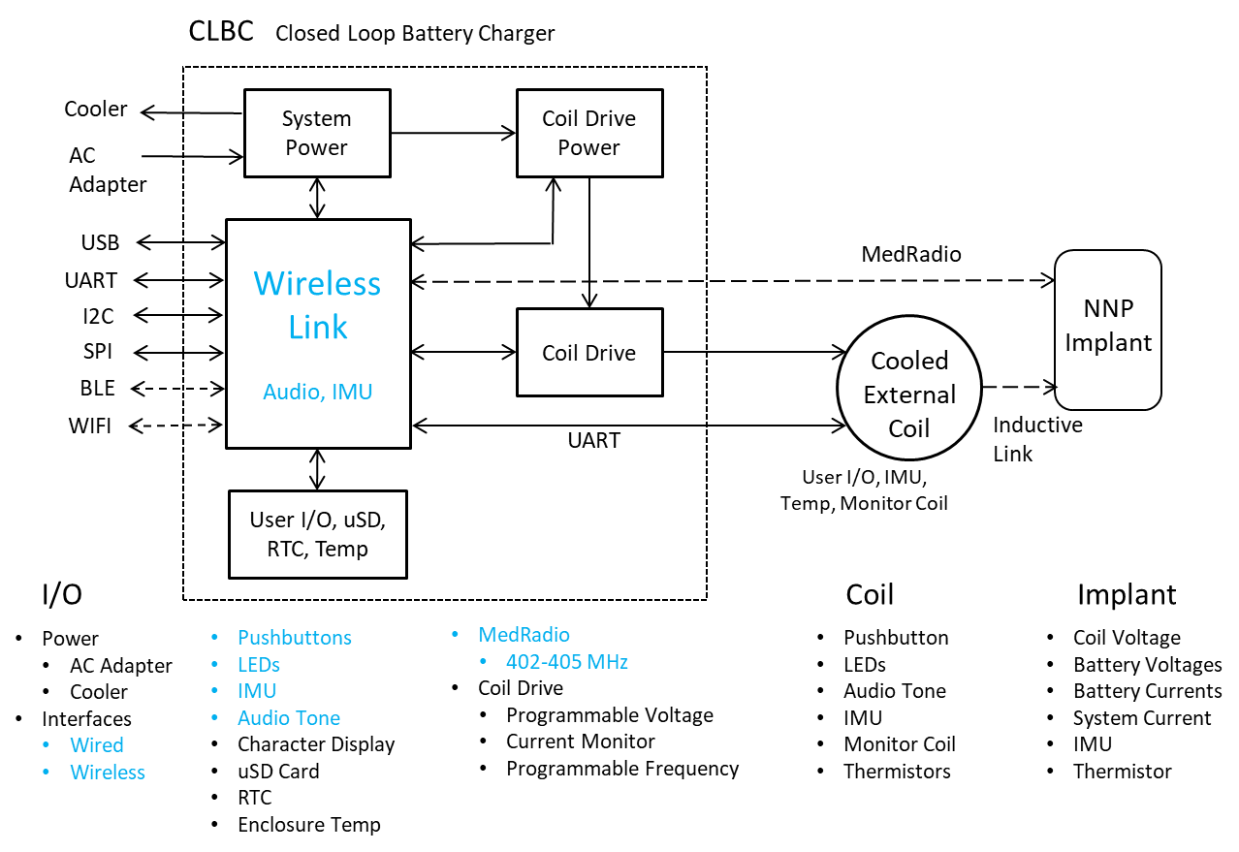

Figure 6. Block Diagram of the Smart Charger System.

Comparing the CLBC prototype (Figure 5) to the SC (Figure 6) illustrates many of the enhancements provided by the Smart Charger. Some enhancements to the CLBC prototype provided by the Smart Charger include;

* The Wireless Link as the main system processor (features shown in blue)
  + nRF 5340 uC
  + BLE
  + WIFI
* uSD memory card
* More flexible System Power
* 4 line character display
* Lower profile enclosure, 1.5” vs. 2.25”

**Smart Charger Rev A Details** - The Smart Charger utilizes the same small enclosure (6.1 x 4.3 x 1.5 inch) used by the LAB 2. This enclosure accommodates all of the features highlighted in Figure 6 above. A schematic of the enclosure is presented in Figure 6. and a mechanical mockup is shown in Figure 7.

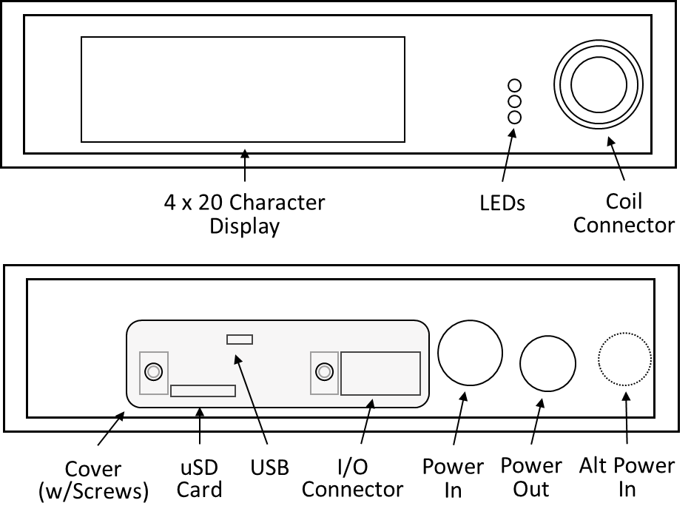

Figure 6. Schematic of the Smart Charger Enclosure.

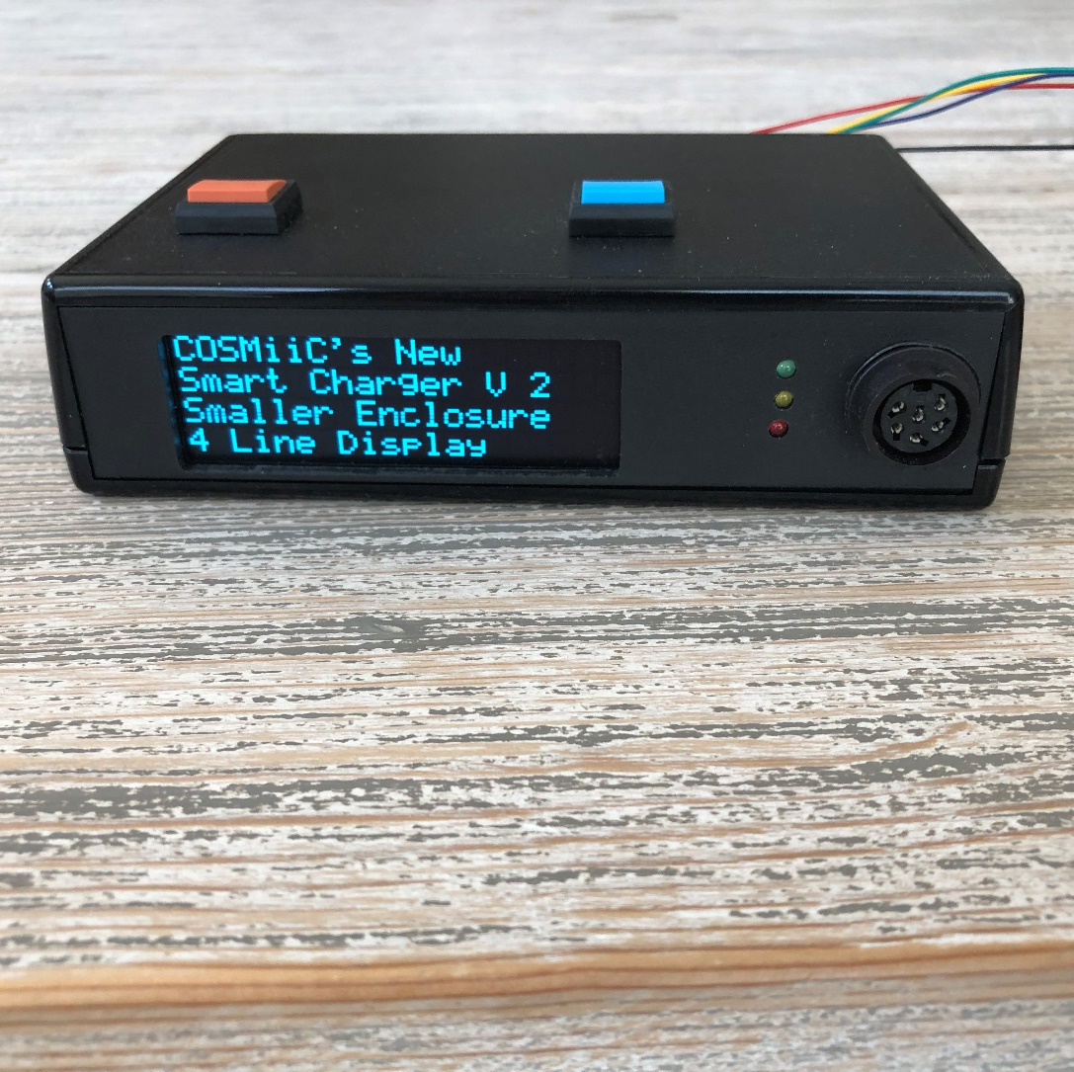

Figure 7. Mechanical Mockup of the 6.1 x 4.3 x 1.5 inch Smart Charger Enclosure.

A 3D rendering of the SC printed circuit board is presented in Figure 8.



Figure 8. A 3D Rendering of the Smart Charger Printed Circuit Board.

The following section details the SC circuitry shown in the rendering above. First, a discussion of the power system is presented in three parts, Overview, Test Points, and a Detailed Circuit Description.

*Power Flow Overview* - A block diagram of the SC power flow is illustrated in Figure 9.

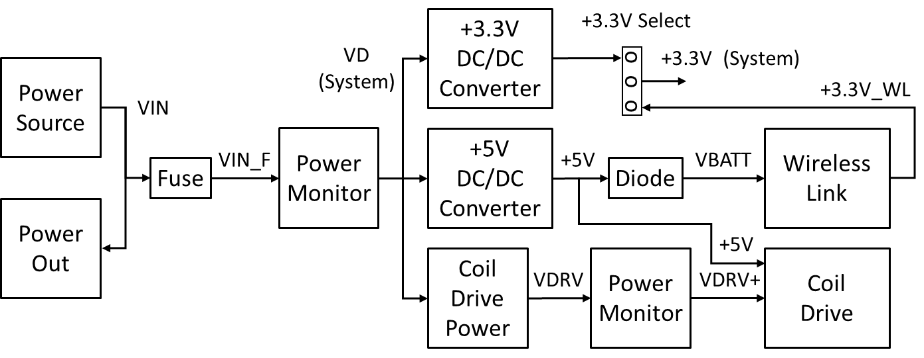

Figure 9. Smart Charger Power Flow Overview Block Diagram.

Following the above diagram from left to right first is the Power Source. The SC is designed to use the same AC power adapter used by the Control Tower. The AC adapter is rated at 12V 8A. It uses an eight-pin DIN connector. The Power Source is made available to the Power Out connector. This connector provides power to the ThermaZone coil cooling device through a power cable. There is an optional barrel style power connector that can be populated to accommodate other styles of power sources. In addition, there is an optional connector on the PCB available for an on-board battery. It should be noted that there is no battery charging circuitry to support the battery. In the past, we have used removable rechargeable battery packs, such as the one used for the KickStart Coil prototype based on the LAB 2.

VIN from the Power Source is fused and becomes VIN_F. VIN_F is monitored by an I2C Power Monitor circuit that measures voltage and current, and can calculate system power consumption. The monitored VD is distributed to three buck/boost DC/DC converter circuits that provide various voltages for other system circuits.

The +3.3V DC/DC converter can provide the system +3.3V, or alternatively the WL can provide the system +3.3V via the +3.3V_WL. The +3.3V Select jumper is used to select the system +3.3V source.

The +5V DC/DC converter provides the system +5V. The +5V is used by the Coil Drive. The +5v also can be jumpered to provide power through a diode to the WL VBATT input.

VDRV is provided by the I2C programmable Coil Drive Power DC/DC converter. Alternately, VDRV can be provided by an externally connected supply. VDRV is monitored by another I2C Power Monitor and becomes VDRV+ for the Coil Drive.

*Power Flow Test Points* - A power signal flow diagram is presented in Figure 10.



Figure 10. Smart Charger Power Signal Flow Test Points Diagram.

The power signal flow follows the same left to right power flow as presented in the power flow overview in Figure 9. The reference designators are the same ones used in the SC schematic. The schematic and PCB locations will be presented in detail in the next section. The above Power Signal Flow Test Points Diagram will prove to be useful for testing and troubleshooting the SC circuitry.

*Detailed Circuit Description* - This section provides a detailed look at the various power systems for the SC. Each system provide a snippet of the schematic and a PCB silkscreen view with highlights of the schematic elements. The breakdown is;

* VIN
* VD
* +3.3V
* +5V
* VDRV
* VDRV+
* VDRV_OUT

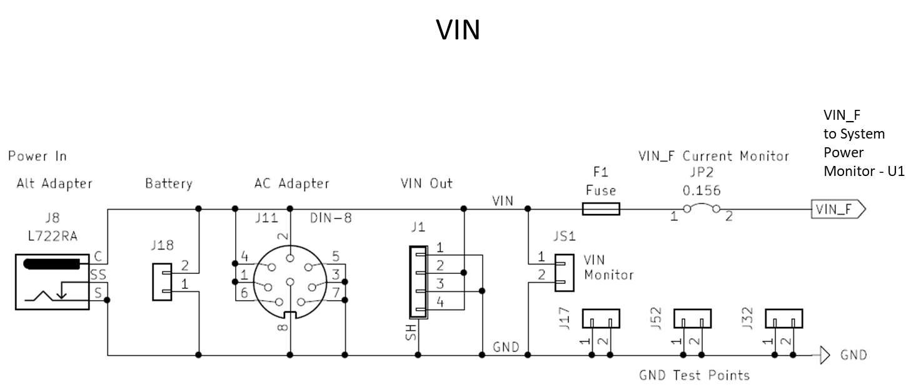

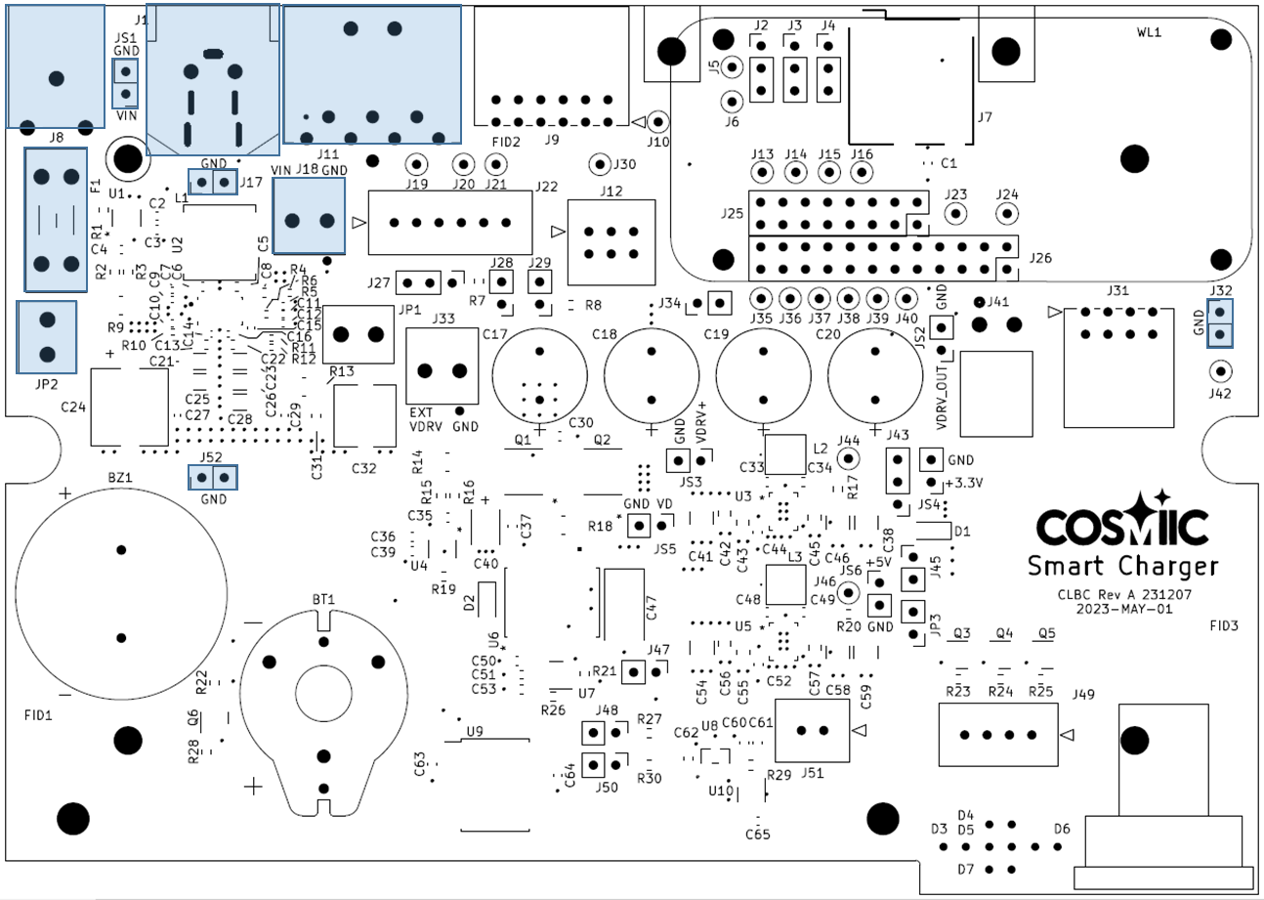

VIN is typically provided by an AC power adapter connected to the DIN connector J11. VIN is nominally 12V DC. J8 provides an alternative input using a barrel type connector. J18 provides a connector for a battery as an alternative VIN source. J1 provides a VIN output for the ThermaZone cooler for an AC adapter appropriately sized. JS1 is a convenient connector for monitoring VIN during testing/troubleshooting. VIN is fused (F1) and then current shunted (JP2), to provide a convenient connection for total system current measurement, to become VIN_F. Three two pin ground connectors (J17, J32, J52) are provided for easy test equipment grounding.



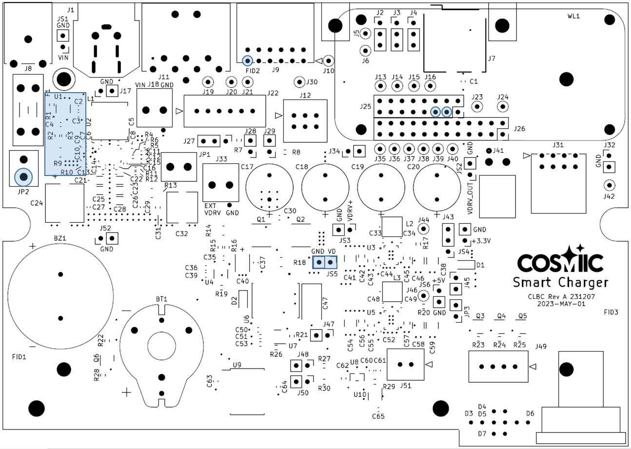

VD provides a power monitored (U1) nominal 12V system voltage. The fused VIN (VIN_F), which becomes VD, is monitored for voltage and current using the Texas Instruments INA236 ([INA236 48-V, 16-Bit, Ultra-Precise, Current, Voltage, and Power Monitor With an I2C Interface datasheet (Rev. D) (ti.com)](https://www.ti.com/lit/ds/symlink/ina236.pdf?ts=1723155745042&ref_url=https%253A%252F%252Fwww.ti.com%252Fproduct%252FINA236%253Fbm-verify%253DAAQAAAAJ_____1Toe2BFNpV0-gV2qIcXPe2EZG5SfQdjbyAg7wRjwmLjPvWcwvxeMuX_udhisa-TexjiQk06Q26x3eAM2aNzbJOeoYSEScj5DRpacE0Yvb5mvhAoVMMe5fGXjDaf7eZ-VKT23lMzuEA30q0j2r8eWqPyQn9X7IftO5YtQ85AJ5OEdJFzmgW8YfS4stB20KrLKR4Pce2R0GzZsFFHPI4FKReHrCUMI_dFALcnp7GOFgqYJn1rd-7uz5Tt7OW6q5xr0nwSm8_7w3tI5dWqu6Jki_jBerUMgC6XPkege4RLt1rtSv3duHHuRAPu)). A shunt resistor of 0.01 ohms (R9) provides a maximum input current of 8.192A with a resolution (LSB) of 25uA. The VIN_F voltage measurement has a resolution of 1.6mV. A spreadsheet is used to calculate the ADC values “INA236 Shunt R 240809.xlsx”.

JS5 provides a convenient connector to monitor VD. VD is used as the input for the 3.3V, 5V, and VDRV DC/DC converters.



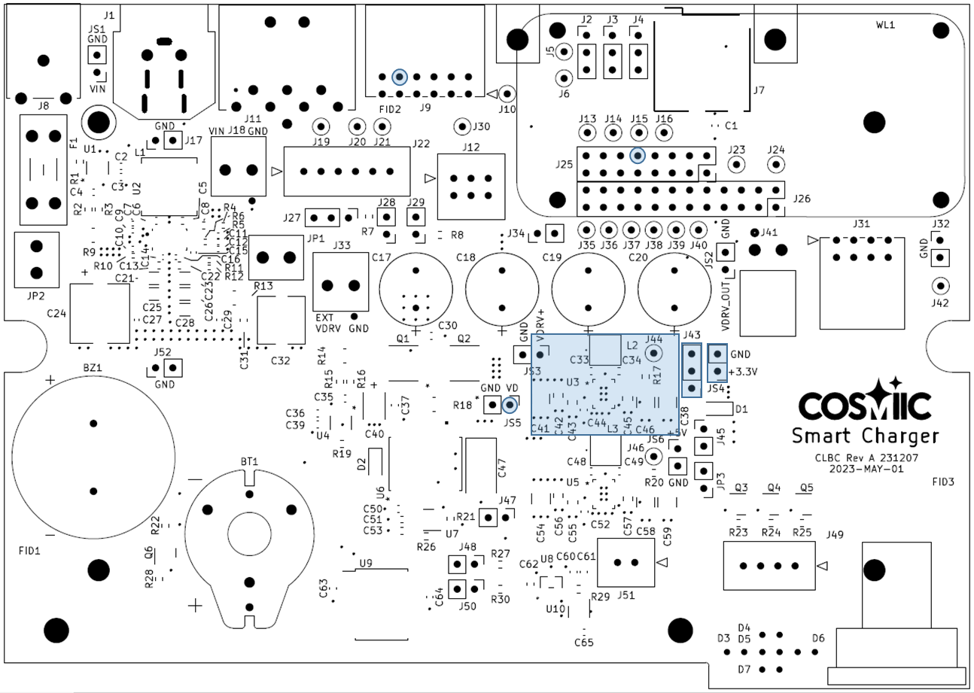

The +3.3V provides the system logic voltage. A DC/DC converter (U3) generates 3.3V from the nominal 12V VD. The Linear Tech LTC3130 buck boost converter is used. The data sheet is here; <https://www.analog.com/media/en/technical-documentation/data-sheets/3130f.pdf>.

J43 is used to select the source of the +3.3V for the system. It is either the output of the DC/DC converter or sourced from the WL daughterboard. Additionally, J43 provides a easy point to monitor the system +3.3V current. JS4 provides a convenient connector to monitor the system +3.3V.



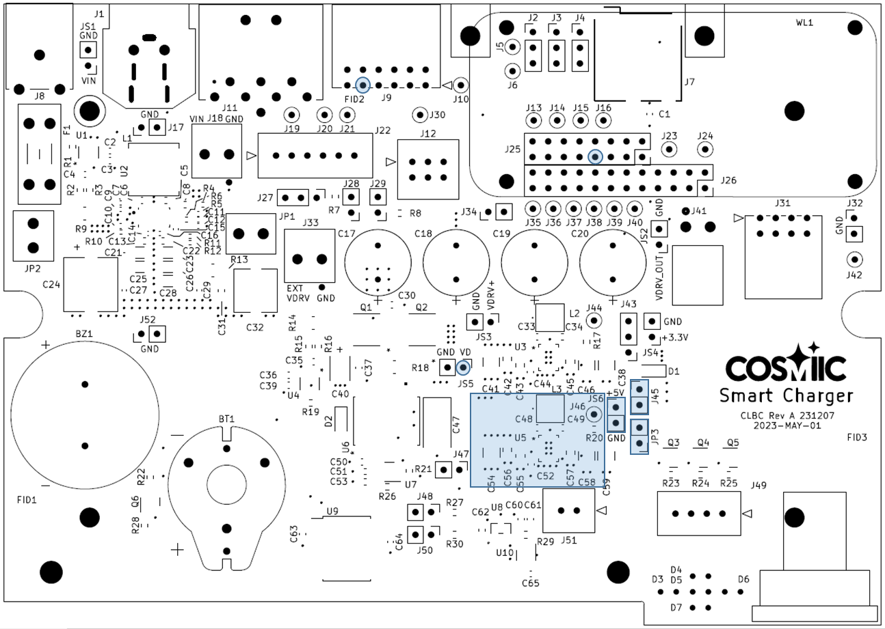

The system +5V provides power for the coil drive and the system I/O connector. It can also provide power to the WL through jumper (J45) and a blocking diode (D1). Another LTC3130 buck boost DC/DC converter (see above) generates the 5V from the system voltage VD. Shunt JP3 provides a connector for measuring current and connector JS6 provides a connector to measure the voltage.



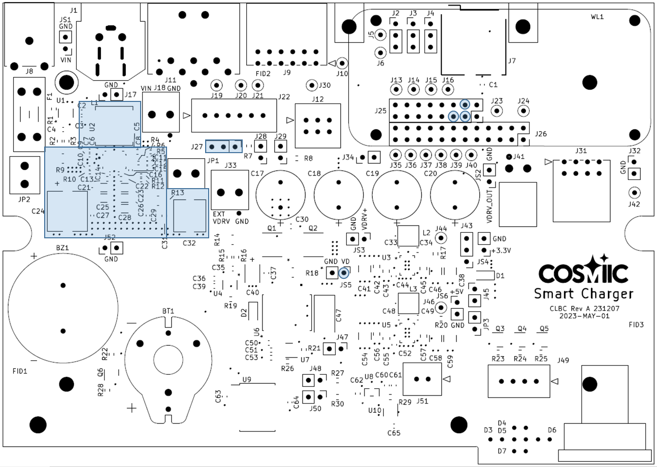

VDRV provides one source of power for the coil drive. Texas Instruments TPS55289 buck-boost DC/DC converter (U2) provides an I2C processor controlled DC voltage for the Coil Drive ([TPS55289 30-V, 8-A Buck-Boost Converter with I2C Interface datasheet (Rev. A) (ti.com)](https://www.ti.com/lit/ds/symlink/tps55289.pdf?ts=1723173662014&ref_url=https%253A%252F%252Fwww.ti.com%252Fproduct%252FTPS55289%253Fbm-verify%253DAAQAAAAJ_____xRHIghpIUzsDH4fPSF8uuv2VvzAkFcAMlPSPD1XxpeW6LtUhXcu64hU4b__oMZi29XyzqEmEIiWPXjxo0DdOEF4V63k97_NfpZ_oEWREdFKW1Tv4QUtYMddz80WrVYO3wiBHvCEqbmdd2Wb4I1DYQKyRLPjTPcwzgqIjC28ghVuJDE4spT0kXnr5bBcsoFn_REeUqIpEH--G5EZtdfkzr-34jHxVK19u_fo8fUGQ4NHHDhPdQHEwGplXuLYmk5iVPTYeeO3BLtsa29Gk2DobTXiEorRRAf1H0n9YNnhy65RvugnuNUpQ7sEkHPw7ePu5Z5GHsIXKGXFssb4capQXRmuD6ignJ1W5yamaFyeNtQGfZE)). A spreadsheet was developed for setting the registers in the TPS55289 (TPS55289EVM-093 Vout Set Math 230628.xlsx).



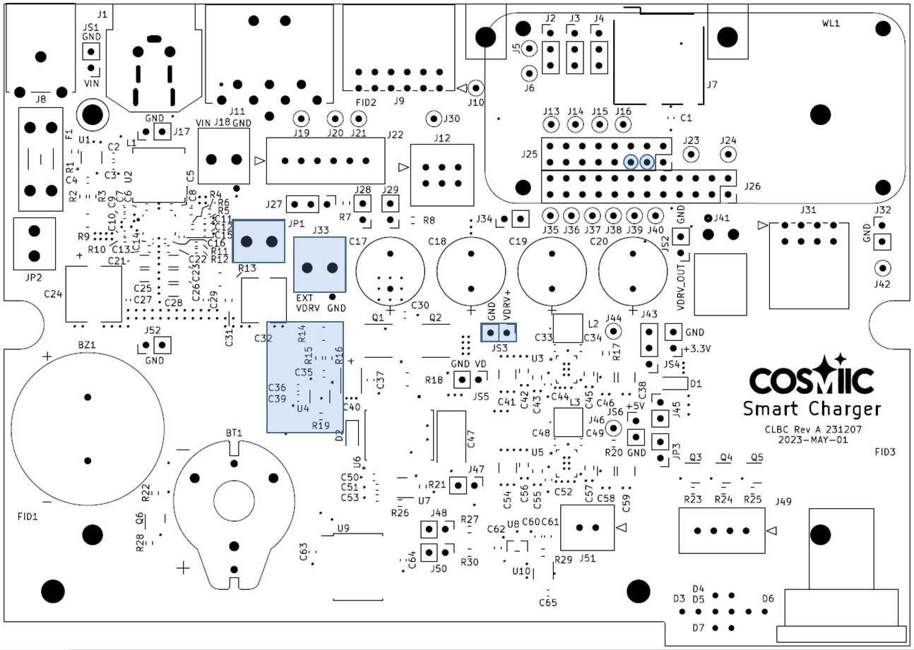

The Texas Instruments INA236 (U4), the same as described in the System Power Measurement section, monitors the power for the drive, VDRV+. VDRV current can also be measured at the shunt JP1. VDRV+ voltage can be monitored at connector JS3. Alternatively, an external power supply can be used by connecting it to J33 and removing the current shunt JP1.



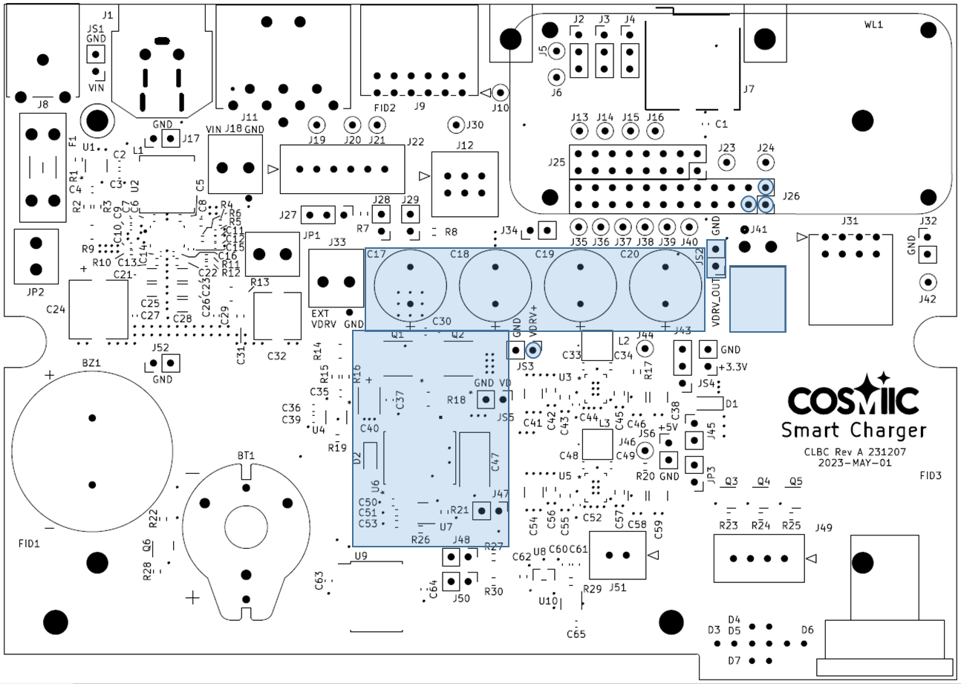

The Coil Drive is essentially the same circuitry used for the Control Tower (CT) Coil Drive daughterboard (NNPS COIL DRIVE 150130). It is based on the Analog Devices LT1158 (U6) Half Bridge N-Channel Power MOSFET Driver([LT1158 - Half Bridge N-Channel Power MOSFET Driver (analog.com)](https://www.analog.com/media/en/technical-documentation/data-sheets/1158fb.pdf)). The WL processor provides output enable logic (EN_DRV), the coil drive frequency (DRIVE A), and can monitor the coil drive fault logic (FAULT_DRV) when jumper J47 is present. The coil drive output (VDRV_Out) can be monitored at connector JS2.

**Configuring the System** – Several system functions need to be configured before using the SC system. They include;

* Various System Power Supplies
* I/O Connector SPI
* Optional I2C Pullup Resistors
* Optional Pushbutton Switches Pullup Resistors
* Onboard Audio Enable

The following section details the configuration of the various system functions.

**Various System Power Supplies** – The SC provides several system power supplies. Details of the power supplies are described above. The following section describes configuring the power supplies.

*VIN* – VIN is typically provided by an external 12V 8A DC desktop AC power adapter. This adapter is connected to the DIN connector (J11) or to the optional barrel connector (J8). Alternatively, a connector is provided (J18) for a battery or bench supply. Only use a single VIN power source. Also note that there is no support for battery charging. A VIN Out connector (J1) provides a VIN output for the ThermaZone coil cooler. It could also serve as a third alternative connector for the AC power adapter. A VIN current shunt (JP2) provides a convenient means to measure VIN current and a VIN voltage monitor connector (JS1) provides easy access to measure VIN voltage.



*+3.3V (System)* – There are two sources of +3.3V for the System. An onboard buck/boost converter or the WL’s 3.3V supply (+3.3V_WL (J26-9)). A jumper (J43) selects between the two sources. The System 3.3V current could be measured at this connector. A +3.3V System Voltage Monitor connector (JS4) is also provided.



*+5V (System)* – The +5V System provides power to the Coil Drive and can be configured to provide power to the WL through the BATT input (J25-8).



*VDRV* - VDRV provides one source of power for the coil drive. An I2C controlled DC/DC converter (U2) provides a programmable voltage. The I2C target address is selected with a jumper (J27).



*+VDRV* - +VDRV provides the selected power source for the coil drive. The current shunt (JP1) selects the onboard DC/DC converter (U2) as the power source. Alternatively, an external power supply can be used by connecting it to VDRV In (J33). Be sure to remove the current shunt JP1. VDRV+ voltage can be monitored at connector JS3.



**I/O Connector SPI** – The system I/O connector (J9) provides several I/O interfaces. Among them is SPI. Three jumpers allow selection of one of two SPI interface sources for the I/O connector. The source is either the high speed Micro SD card or the CC1101 MedRadio. In addition, three solder pads provide the ability to sky wire other signals to the I/O connector SPI pins.



**Optional I2C Pullup Resistors** – The SC adds additional trace length to the WL’s I2C lines. Two jumpers (J48, J50) provide the option to add additional 10K ohm pullup resistors (R27, R30) to the I2C bus SDA and SCL lines.



**Optional Pushbutton Switches Pullup Resistors** - The SC adds additional trace length to the WL’s pushbutton switch lines. Two jumpers (J28, J29) provide the option to add additional 10K ohm pullup resistors (R7, R8) to the pushbutton switches SW1 and SW2 lines.



**Onboard Audio Enable** – The SC includes a large audio buzzer and drive circuitry to enhance the WL buzzer’s output. A jumper (J34) enables the additional SC Audio buzzer.



**Offboard Connectors** – Various connectors provide connections to offboard devices.



**Theory of Operation** – The Smart Charger (SC) system provides recharging of the implanted NNP Power Module batteries in a multiple component, user controlled, system. The SC system consists of the cooled Smart Coil, a small electronics enclosure for the Coil Drive System Power, the ThermaZone cooling device, and desktop AC power adapter.

The SC system is a small enclosure that contains the coil drive circuitry and provides various user inputs and outputs. It is powered by a desktop AC adapter, which can also provide power to the ThermaZone coil-cooling device. The SC provides the necessary functions for charging the NNP Power Module. A system diagram of the SC system is shown in Figure 2.





Figure 2. Smart Battery Charger (SC) System Diagram.

A description of each component of the SC system follows.

*Smart Coil* – The Smart Coil is positioned above the implanted NNP Power Module (PM). It contains the inductive coil used to transcutaneously transfer power from the SC to the PM (Transcutaneous Energy Transfer (TET)). The Smart Coil also contains a uC that interfaces to several sensors and transducers, as depicted in the above figure. The uC receives power from, and communicates serially, via a UART, with the SC Coil Drive Power System electronics. The uC system utilizes four conductors and the inductive coil uses two conductors, for a six conductor coil cable connected to the SC electronics enclosure. In addition, the Smart Coil provides active cooling via chilled water from the ThermaZone cooling device.